PAPER TITLE – USE CAPITAL LETTERS, CENTER, BOLD, TIMES NEW ROMAN, SIZE 12, DO NOT USE ABBREVIATIONS HERE

Family Name Ferst Nameª, Family Name Ferst Name^{b*} - Times New Roman, Size 12
ª Name of the Department/Institute, University/Company, Contry, e-mail ORCID XXXX-XXXX-XXXX-XXXX - Times New Roman, Size 10
^{b} Name of the Department/Institute, University/Company, Contry, e-mail ORCID XXXX-XXXX-XXXX-XXXX - Times New Roman, Size 10
*Corresponding author:email: Jan.Kowalski@urk.edu.krakow.pl
Abstract: Brief description of the study and used methods – min 1000 char. /Times New Roman, Size 10/
Key words: keyword1, keyword2, keyword3…- max 5 keywords /Times New Roman, Size 10/
Introduction – Times New Roman, bold, 12
The article should consist of sections: Introduction, Material and Methods, Results and Discussion, Conclusions, Bibliography.
Please note that the full paper should not exceed 8 pages including text, figures and tables.
- Language: Papers should be written in English or Polish Language.
- Font: Times New Roman, Size 12, Colour Black
- Page Setup: It is strongly recommended to observe this given paper format. We kindly advise you to input your paper text in this document which is already properly formatted.
- Size: A4 paper, Portrait
- Margins: Left/Right 2,5 cm, Top/Bottom 2,5 cm.
- Alignment: Justify, Line Spacing Single.
Use of standard abbreviations is acceptable. Place spe-cial or unusual abbreviations in parentheses after the full term for the first time it appears. Lin-guistic accuracy is the responsibility of the authors.
- Units: given in round brackets
Tables: number each table and put table headings above the table – Align Left.
Figures and images: number each figure, put figure caption under the figure,
Formula: Formula should be typewritten (use, e.g., Microsoft Equation Editor).

Tables: Font: Times New Roman, Size 9, Colour Black
Table 1.
Organization of agricultural production
Specification | Production branch
 | vegetable | fruit | plant | dairy | livestock | mixed | average
Arable land (ha) | 7.00 | 1.91 | 6.50 | 6.43 | 2.97 | 4.84 | 5.48
Including:
Cereals | 2.06 | 0.90 | 3.64 | 1.48 | 1.76 | 2.31 | 2.09
Roots | 0.62 | 0.03 | 0.28 | 0.23 | 0.11 | 0.12 | 0.24
Fodders | 0.82 | 0.88 | 1.48 | 4.67 | 0.99 | 2.27 | 2.48
Vegetables | 3.50 | 0.11 | 0.30 | 0.04 | 0.12 | 0.14 | 0.50
Herbs | – | – | 0.80 | – | – | – | 0.17
Agricultural land (ha) | 8.34 | 3.45 | 13.80 | 20.06 | 4.88 | 8.03 | 12.66
Livestock density (LSU·ha⁻¹) | 0.86 | 0.19 | 0.69 | 0.67 | 0.32 | 0.45 | 0.60
Figures: Font: Times New Roman, Size 9, Colour Black

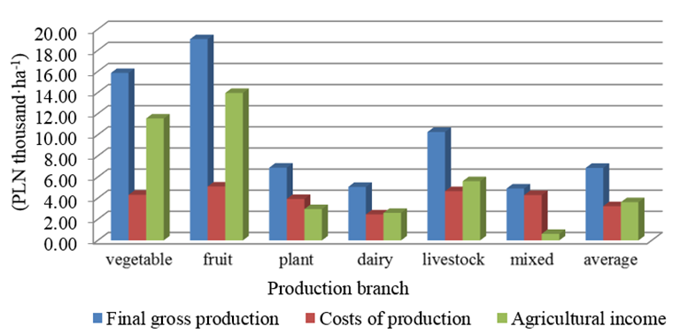
Figure 1. Gross unit final production, production costs and agricultural revenue
Formula: Font: Times New Roman, Size 10
$Mi=Am+Ab+Ir+(Wb-Wp)$ (1)
where:
Am – Depreciation of technical means
Ab – Depreciation of buildings and facilities
Ir – Development investments
Wb – Gross balance income of the farmer's family
Wp – Parity pay

References should be used in accordance with the example: Modern agricultural engineering is looking for "safe" methods of improving the quality of crops using an interdisciplinary combination of mathematics, biophysics, agronomy, molecular biology and physics (Cieśla et al., 2015). Research tasks, including mathematical modeling of agribiological processes, are carried out as part of agricultural engineering and its ongoing operations (Kowalski and Nowak, 2015, Michałek, 2008).
Material and Methods
Materials and Methods should be described with sufficient details to allow others to replicate and build on published results.
Results and Discussion
This section it should provide a cexperimental results and their inter-pretation. Authors should discuss the results and how they can be interpreted in perspective of previous studies and of the working hypotheses. The findings and their implications should be discussed in the broadest context possible.
Conclusions – min 1000/1500 char
Summarize the results of the research/paper and write the conclusion with a few sentences here; Articles without conclusions will NOT be published.
Acknowledgements
This section is optional.
References /Styl APA/

Alvarado, V., Bradford, K.J. (2002). A hydrothermal time model explains the cardinal temperatures for seed germination. Plant, Cell & Environment 25, 1061-1069.

Białobrzeski, I., Markowski, M., Bowszys, J., Myhan, R. (2005). Symulacyjny model zmian pola temperatury w silosie zbożowym. Inżynieria Rolnicza, 8(68), 23-30.

Gładyszewska B. (1998). Ocena wpływu przedsiewnej laserowej biostymulacji nasion pomidorów na proces ich kiełkowania. Rozprawa doktorska. Lublin. Maszynopis.

Shafii, B., Price, W.J., Swensen, J.B., Murray, G.A. (1991). “Nonlinear Estimation of Growth Curve Models for Germination Data Analysis”, in Proceedings of the 1991 Kansas State University Conference on Applied Statistics in Agriculture, G. A. Milliken, J. R. Schwenke (eds.), Manhattan, KS: Kansas State University, 19-42.

Zeide, B. (1993). Analysis of growth equations. Forest Science, 39, 594-616.

Remark:
Papers without REFERENCES will not be accepted!
Every text citation must be listed under the heading REFERENCES at the end of the text. In the text, every reference should be quoted at least once with indices in the form: (Kowalski, 2019); (Nowak and Kowalski, 2018), …, etc. (but include all names in the reference list in case there are more than one author per quoted material).

TYTUŁ ARTYKUŁU W JĘZYKU POLSKIM
Streszczenie. Times New Roman, 10

Słowa kluczowe: Times New Roman, 10

